 |  | EDUCATIONAL FISCOMISIONAL UNIT AUGUST 10  Código AMIE 08H01199  San Lorenzo-Ecuador |  |  |  |  |  |  | 
MICROCURRICULAR PLANNING 2026 – 2027
FIRST QUARTER
- INFORMATIVE DATA
TEACHER´S NAME: | YANET SOLIS |  |  | ÁREA: |  |  | FOREIGN LANGUAGE | SUBJECT: |  | ENGLISH
TEACHING UNIT: | CURRICULAR APPROACH |  |  | Título de la unidad didáctica: |  |  | “Greeting and Introducction/ All about People
GRADE/COURSE: | 9th A, B, C,D |  |  | No. of Week |  |  | 7 | START AND END DATE: |  | FROM JUNE 15 TO JULY 31, 2026
- LEARNING OBJETIVES
CE.EFL.4.7. Listening for Information: Follow and identify some main ideas and details in short and straight-forward spoken or audio texts set in familiar contexts, when delivered slowly and with visuals to provide contextual support. Use spoken contributions in class as models for one’s own speech.
O.EFL 4.1 Identify the main ideas, some details and inferences of written texts, in order to produce level-appropriate critical analysis of familiar subjects and contexts. O.EFL 4.2 Appreciate and value English as an international language and a medium to interact globally. O.EFL 4.3 Independently read A2.1 level text in English as a source of entertainment and interpersonal and intrapersonal interaction. O.EFL 4.4 Develop creative and critical thinking skills when encountering challenges in order to promote autonomous learning and decision making. O.EFL 4.5 Introduce the need for independent research as a daily activity by using electronic resources (ICT) in class while practicing appropriate competences in the four skills. O.EFL 4.6 Write short descriptive and informative texts related to personal information or familiar topics and use them as a means of communication and written expression of thought. O.EFL 4.7 Use spoken and written literary text in English such as poems, short stories, comic strips, short magazine articles and oral interviews on familiar subjects in order to inspire oral and written production at an A2.1 level. O.EFL 4.8 Integrate written and spoken text in order to identify cultural differences and similarities within a range of local, national and global contexts familiar to the learner. O.EFL 4.9 Create a sense of awareness in terms of accuracy when learners interact in English using high-frequency and level-appropriate expressions in order to reach an effective command of spoken language.
- INSERCIÓN CURRICULAR |  |  |  |  |  | - VALUES
Social-Emotional Education  Sustainable Development  Road Safety  Financial Education  Civic Education |  |  |  |  |  | June: Generosity  July: Perseverance.
- STANDARDS:
CE.EFL.4.6. Listening for Meaning: Understand and follow the main idea in spoken texts set in familiar everyday contexts, provided speech is clear and articulate, and deduce the meanings of unfamiliar words and phrases using context clues and/or prior knowledge.
CE.EFL.4.7. Listening for Information: Follow and identify some main ideas and details in short and straight-forward spoken or audio texts set in familiar contexts, when delivered slowly and with visuals to provide contextual support. Use spoken contributions in class as models for one’s own speech.
CE.EFL.4.3. Interact with others using self-monitoring and self-correcting strategies as well as appropriate nonverbal and oral communication features.
CE.EFL.4.9. Production – Fluency: Use simple language to describe, compare and make statements about familiar everyday topics such as objects, possessions and routines in structured situations and short conversations. Interaction is with reasonable ease, provided speech is given clearly, slowly and directly.
CE.EFL.4.10. Interaction – Interpersonal: Participate effectively in familiar and predictable conversational exchanges by asking and answering follow-up questions, provided there are opportunities to use repair strategies (e.g. asking for clarification) and sustain conversational exchanges in pairs to complete a task, satisfy a need or handle a simple transaction.
CE.EFL.4.11. Demonstrate comprehension of main ideas and some details in short simple texts on familiar subjects, making use of contextual clues to identify relevant information in a text.
CE.EFL.4.15. Express information and ideas and describe feelings and opinions in simple transactional or expository texts on familiar subjects in order to influence an audience, while recognizing that different texts have different features and showing the ability to use these features appropriately in one’s own writing.
CE.EFL.4.16. Make use of simple learning resources, including those created by one’s self, in order to compare and contrast information, and choose appropriate resources according to the value, purpose and audience of each.
- PLANNING:
ESSENTIAL  CONTENTS | SKILL WITH PERFORMANCE CRITERIA |  | EVALUATION INDICATORS | ACTIVE METHODOLOGICAL STRATEGIES FOR TEACHING AND LEARNING |  |  |  |  |  |  | EVALUATION  ACTIVITIES
WEEK 1  FROM JUNE 15 TO JUNE 19  - Greetings and farewells  - Personal information  - Verb To Be in affirmative, negative and interrogative forms  - WH Questions (What, Where, Who, How old) | EFL 4.2.10. Sustain a conversational exchange on a familiar, everyday subject when carrying out a collaborative/paired learning activity in which there are specific instructions for a task.   EFL 4.2.16. Initiate, maintain and end a conversation to satisfy basic needs and/ or handle a simple transaction. |  | I.EFL.4.10.1. Learners can effectively participate in familiar and predictable everyday conversational exchanges in order to  complete a task, satisfy a need or handle  a simple transaction, using a range of repair strategies. (Example: asking for clarification, etc.) (I.3, J.3, J.4) | GREETING  CLASS OBJECTIVE  - EXPERIENCE:  Dynamic greeting in English.  "Find someone who..." game  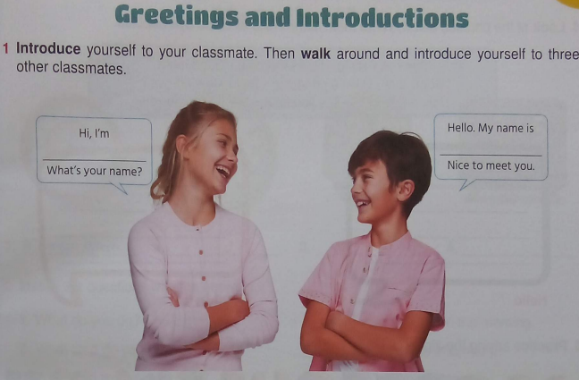  REFLECTION:  - Students identify personal information (Mr, Mrs, Miss).  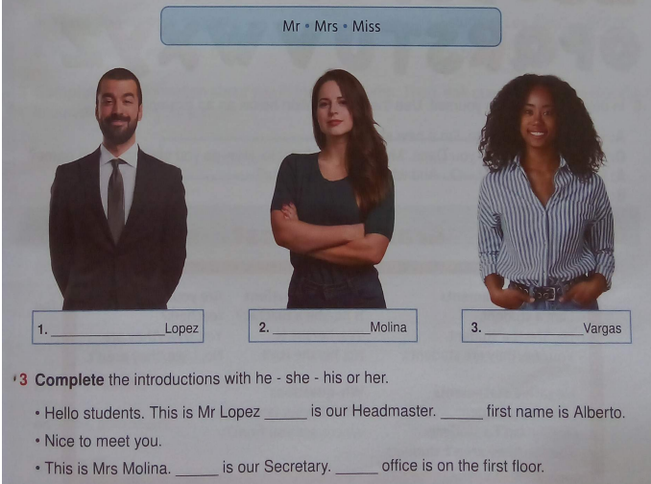  CONCEPTUALIZATION:  Guided explanation of the verb "to be" and WH questions  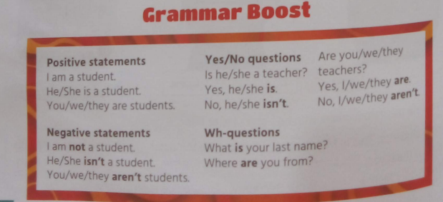  https://www.businessenglishresources.com/learn-english-for-business/teachers-section/grammar-lessons-2/forming-questions-part-1-wh-questions-with-to-be/  APPLICATION:  Peer interviews.  - Personal oral presentation.  - Complete the pag 8. |  |  |  |  |  |  | Technique: Rubric  Instrument: Analytical Rubric  Criteria  Use the Verb To Be correctly.  Formulate WH questions appropriately.  Pronounce personal information clearly.  Actively participates in oral interaction.  Resources  - English textbook  - Flashcards  - QR audio  - Whiteboard  - Markers
WEEK 2  FROM JUNE 22 TO JUNE 26  - Daily activities  - Simple Present  - Time expressions | EFL 4.2.12. Describe habits, routines, past activities and experiences within the personal and educational domains   |  | I.EFL.4.9.1. Learners can use simple language to describe, compare and state facts about familiar everyday topics such as possessions, classroom objects and routines in short, structured situations, interacting with relative ease. (I.3, I.4, S.4) |  | GREETING  CLASS OBJECTIVE  EXPERIENCE  - Observation of images of routines.  https://in.pinterest.com/pin/382876405838626144/  REFLECTION:  Comparison of daily activities pag, 9  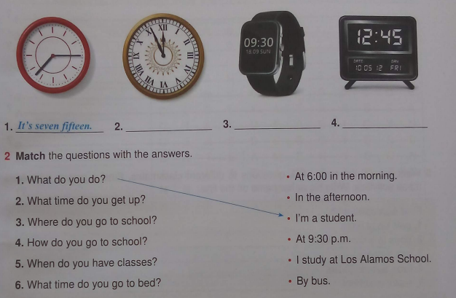  CONCEPTUALIZATION:  • Explanation of structure of the Simple Present.  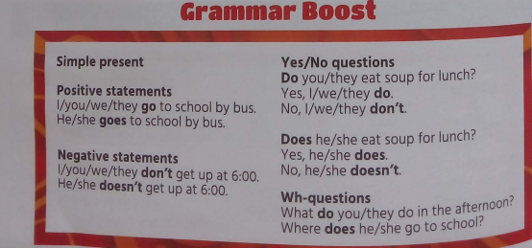  https://www.youtube.com/watch?v=qJ29O8RK08Y  APPLICATION:  • Creating personal schedules.  - Oral description of routines.  - Complete the activities pag 10. |  |  |  |  |  | Technique: Observation  Instrument: Checklist  Criteria  Uses the Simple Present tense correctly.  Organizes sequences of activities.  Uses vocabulary related to routines.  Participates in oral activities.  Resources  - Book  - Personal cards  - Cardboard  - QR code audio
WEEK 3  FROM JUNE 28 TO JULY 3  - Family members  - Possessive nouns  - Family descriptions | EFL 4.1.6. Seek and provide information  and assistance, orally or in writing and  in online or face-to-face interactions, for  personal, social and academic purposes  EFL 4.2.11. Give short, basic descriptions  of everyday activities and events within familiar contexts and use simple descriptive  language to compare and make brief statements about objects and possessions.  (Example: family, school, living conditions,  personal belongings, etc.) |  | I.EFL.4.4.1. Learners can demonstrate an ability to give and ask for information and assistance using level-appropriate language and interaction styles in online or face-to-face social and classroom interactions. (J.2, J.3, J.4, I.3)  I.EFL.4.9.1. Learners can use simple language to describe, compare and state  facts about familiar everyday topics such  as possessions, classroom objects and  routines in short, structured situations, interacting with relative ease. (I.3, I.4, S.4) | GREETING  CLASS OBJECTIVE  EXPERIENCE:  Presentation of family photographs.  Look and complete pag,11  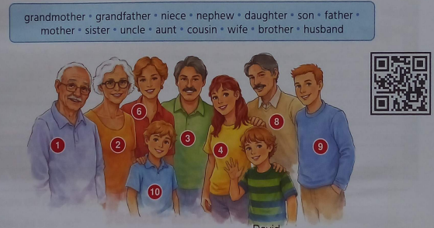  REFLECTION:  . Conversation about family similarities pag,12  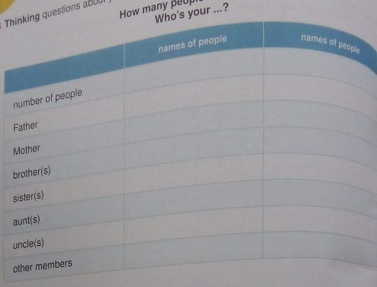  CONCEPTUALIZATION:  Teacher explains: Use of the possessive ('s).  https://www.youtube.com/watch?v=JoyodmbkeKg&t=52s  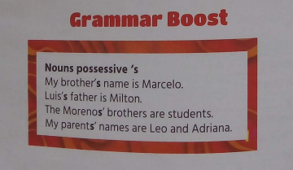  APPLICATION:  - Creating a family tree.  - Describing family members.  - Activities from the book, pag 12 |  |  |  |  |  |  | Technique: Rubric  Instrument: Analytical rubric.  Criteria  Uses possessives correctly.  Identifies family members.  Describes family relationships.  Presents organized information.  Resources  - Book  - Post card  - Audio  - Videos
WEEK 4  FROM JULY 6 TO JULY 10  - Vacation vocabulary  - Regular and irregular verbs  - Simple Past | EFL 4.4.4. Write to describe feelings/ opinions in order to effectively influence an  audience. (Example: persuade, negotiate,  argue, etc.)    EFL 4.5.9. Engage in collaborative activities through a variety of student groupings to create and respond to literature  and other literary texts. (Example: small  groups, cooperative learning groups, literature circles, process writing groups,  etc.)  |  | I.EFL.4.15.1. Learners can convey information and ideas and describe feelings and opinions in simple transactional or expository texts on familiar subjects in order to influence an audience, while recognizing that different texts have different features and showing the ability to use these features appropriately in one’s own writing. (I.3, I.4, S.3, J.2)  I.EFL.4.22.1. Learners can collaborate and participate effectively in a variety of student groupings by employing a wide range of creative thinking skills through the completion of activities such as playing games, brainstorming and problem solving. (S.2, S.4, J.1, J.2, J.3, J.4) | GREETING  CLASS OBJECTIVE  EXPERIENCE  Looking at travel photographs, and complete the pag 13  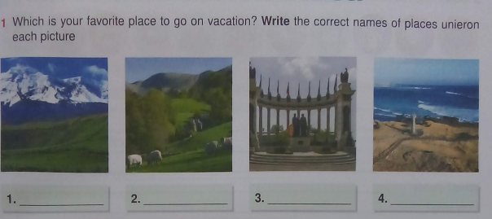  REFLECTION  Discuss with the students: Account of past experiences  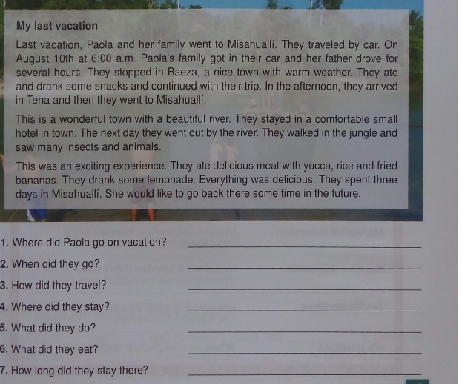  CONCEPTUALIZATION  • Explanation of the structure of the simple past tense.  https://www.youtube.com/watch?v=va_-73AtYiI  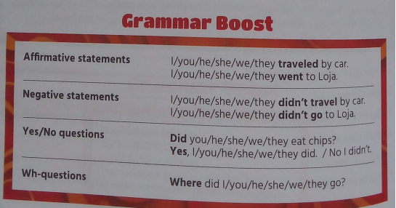  APPLICATION  - Writing about a vacation experience. 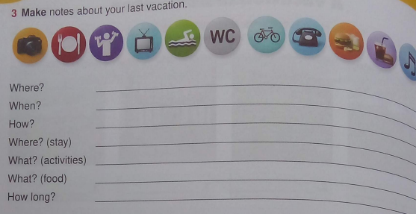  - Complete the activities pag 14.  - Complete the Unit evaluation pag, 15 |  |  |  |  |  |  | Technique: Objective test and rubric.  Instrument: Written questionnaire.  Criteria  Uses verbs in the past tense correctly.  Understands short texts.  Produces coherent sentences.  Participates in oral activities.  Resources  - Book  - World Map  - Flags  - Videos  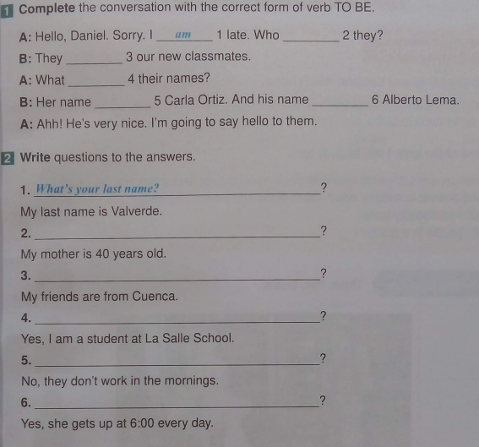
WEEK 5  FROM JULY 13 TO JULY 17  - Physical appearance  - Adjectives  - Be + Have | EFL 4.2.1. Understand phrases and expressions related to areas of most immediate  priority within the personal and educational domains, provided speech is clearly  and slowly articulated. (Example: daily life,  free time, school activities, etc.)  EFL 4.4.7. Use the process of prewriting,  drafting, revising, peer editing and proof  -reading (i.e., “the writing process”) to  produce well-constructed informational  texts. |  | Learners can grasp the general meaning  of spoken texts set in familiar everyday  contexts and infer changes in the topic of  discussion. (Ref.I.EFL.4.6.1.) (I.3, S.1, J.4)  I.EFL.4.17.1. Learners can convey and  organize information through the use of  facts and details and by employing various stages of the writing process, while  using a range of digital tools to promote  and support collaboration, learning and  productivity. (I.1, I.3, S.4,J.2, J.4). | GREETING  CLASS OBJECTIVE  EXPERIENCE  Observation of famous people pag, 16  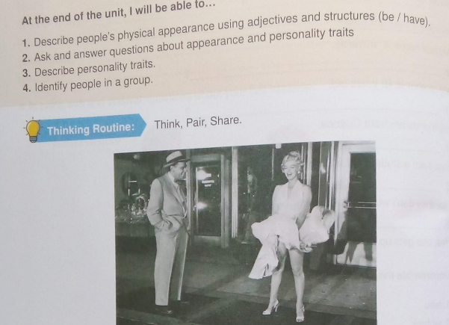  REFLECTION  Discuss with the students: Comparison of physical characteristics. Pag, 17  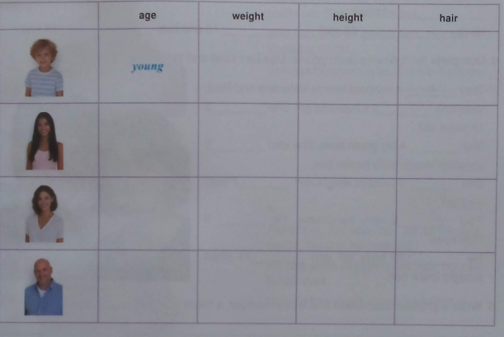  CONCEPTUALIZATION  - Explanation about the Be and Have to describe people.  https://www.youtube.com/watch?v=mHOcR6bS-mc  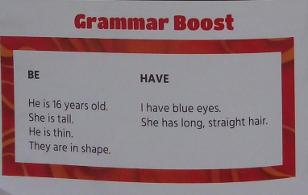  APPLICATION  - Oral description of your family.  - Book activities.pag, 17  - Listen the descriptions pag, 18 |  |  |  |  |  |  | Technique: Rubric  Instrument: Checklist.  Criteria  Describes physical features accurately.  Uses "be" and "have" appropriately.  Uses specific vocabulary.  Presents clear ideas.  Resources  - Book  - Flashcards  - Photographs  - Descriptive cards  - Student book
WEEK 6  FROM JULY 20 TO JULY 24  - Physical descriptions  - Questions with How Long  - Hair and eye color vocabulary | EFL 4.2.1. Understand phrases and expressions related to areas of most immediate  priority within the personal and educational domains, provided speech is clearly  and slowly articulated. (Example: daily life,  free time, school activities, etc.)  EFL 4.2.5. Understand most changes in  the topic of discussion if people speak  slowly. |  | Learners can grasp the general meaning of spoken texts set in familiar everyday contexts and infer changes in the topic of discussion. (Ref.I.EFL.4.6.1.) (I.3, S.1, J.4) | GREETING  CLASS OBJECTIVE  EXPERIENCE  Look at the pictures. Match them with their corresponding description.  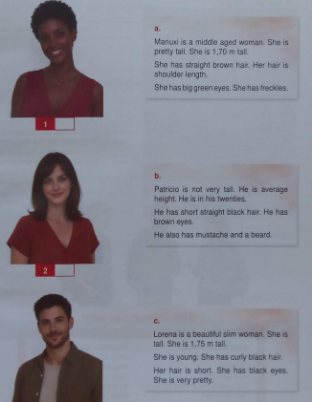  REFLECTION  Discuss with the students: Analysis of descriptions Pag, 20  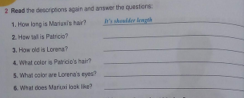  CONCEPTUALIZATION  Explanation about formation of descriptive questions.  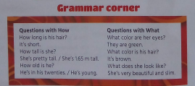  APPLICATION  - Peer interviews.  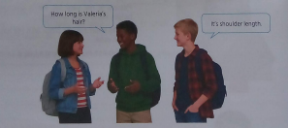  - Complete the Reading comprenhension pag, 21  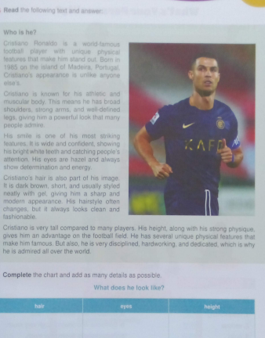 |  |  |  |  |  |  | Technique: Systematic observation  Instrument: Rating scale.  Evaluation criteria:  Formulates questions correctly.  Describes physical characteristics.  Participates in conversations.  Understands spoken information.  Resources  - Book  - Flashcards  - Photographs  - Descriptive cards  - Student book
WEEK 7  FROM JULY 27 TO JULY 31  - Personality adjectives  - Relative pronouns (Who)  - Oral presentations | EFL 4.2.11. Give short, basic descriptions  of everyday activities and events within familiar contexts and use simple descriptive  language to compare and make brief statements about objects and possessions.  (Example: family, school, living conditions,  personal belongings, etc.)   EFL 4.4.2. Make and use a simple print or  digital learning resource to compare and  contrast information in order to demonstrate understanding and command of a  topic.   |  | I.EFL.4.9.1. Learners can use simple language to describe, compare and state  facts about familiar everyday topics such  as possessions, classroom objects and  routines in short, structured situations, interacting with relative ease. (I.3, I.4, S.4)  Learners can create and use simple print  or digital learning resources to compare  and contrast information on a topic, demonstrating understanding, and can critically evaluate and recommend appropriate sources based on their value, purpose,  and audience. (Ref.I.EFL.4.16.1.) (I.1, I.3,  I.4, J.2, J.4) | GREETING  CLASS OBJECTIVE  EXPERIENCE  - Label the pictures with the words of chart in each image Pag,22  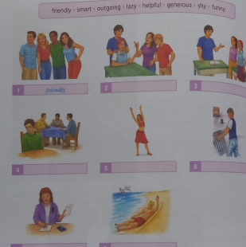  REFLECTION  Discuss with the students : Listen to the conversation and write their personality traits. Pag, 23  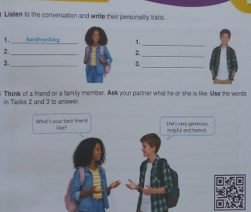  CONCEPTUALIZATION  Explanation of the use of Who and personality vocabulary pag, 24  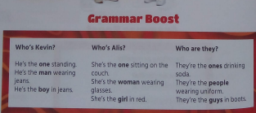  APPLICATION  - Oral presentation about a favorite famous person. Pag, 25  - Complete Unit Evaluation 2 on pages 26-27. |  |  |  |  |  |  | Technique: Rubric for Oral Presentation  Instrument:  Analytical rubric.  Evaluation Criteria:  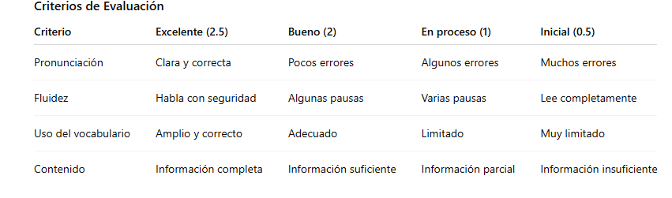  Resources  - English textbook  - Flashcards  - QR audio  - Whiteboard  Markers  Technique: Objective Test  Instrument: Evaluation Questionnaire from the textbook  Evaluation Criteria:  Recognizes vocabulary from the unit.  Identifies family relationships.  Understands short texts and responds appropriately.  Applies the content covered during the unit.  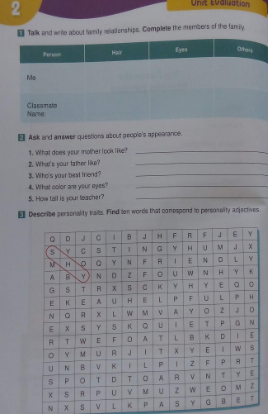  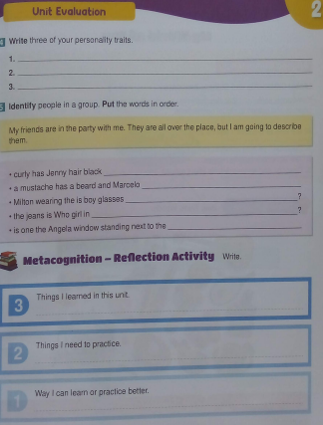
ESTUDIANTES CON NECESIDADES EDUCATIVAS ESPECÍFICAS: En esta sección se plasman las estrategias dirigidas a los estudiantes con necesidades educativas específicas ligadas o no a la discapacidad.
CONTENIDOS ESENCIALES | DESTREZAS CON CRITERIOS DE DESEMPEÑO |  | INDICADORES DE EVALUACIÓN | ESTRATEGIAS METODOLÓGICAS ACTIVAS PARA LA ENSEÑANZA Y APRENDIZAJE |  |  |  |  |  |  | ACTIVIDADES EVALUATIVAS
Basic personal information using greetings and simple expressions. | EFL 4.2.10. Sustain a conversational exchange on a familiar, everyday subject when carrying out a collaborative/paired learning activity in which there are specific instructions for a task.  EFL 4.2.16. Initiate, maintain and end a conversation to satisfy basic needs and/ or handle a simple transaction. |  | I.EFL.4.10.1. Learners can effectively participate in familiar and predictable everyday conversational exchanges in order to  complete a task, satisfy a need or handle  a simple transaction, using a range of repair strategies. (Example: asking for clarification, etc.) (I.3, J.3, J.4) | Experience  Look the pictures of people greeting each other.  Reflection  Recognize greetings in short audio recordings.  Conceptualization  Learn basic expressions:  Hello  My name is...  I am...  Application  Introduce yourself using an illustrated personal information card. |  |  |  |  |  |  | Technique  Direct observation.  Instrument  Checklist.  Criteria  ✔ Greets correctly.  ✔ States their name.  ✔ Recognizes images related to greetings.  ✔ Participates with teacher support.  Resources  Visual cards  Flashcards  Mirror for oral practice  Notebook
My Daily Routine – Simple Present | EFL 4.2.12. Describe habits, routines, past activities and experiences within the personal and educational domains |  | I.EFL.4.9.1. Learners can use simple language to describe, compare and state facts about familiar everyday topics such as possessions, classroom objects and routines in short, structured situations, interacting with relative ease. (I.3, I.4, S.4) | Experience  Observation of routine sequences.  Reflection  Guided conversation about daily activities.  Conceptualization  Vocabulary:  Wake up  Eat  Study  Sleep  Application  Order images according to the correct sequence. |  |  |  |  |  |  | Evaluation  Technique  Observation.  Instrument  Checklist.  Criteria  ✔ Identifies daily activities.  ✔ Matches image to word.  ✔ Orders sequences correctly.  ✔ Participates in the activity.  Resources  Sequential images  Index cards  Illustrated cards
My Family – Possessive Nouns | EFL 4.2.11. Give short, basic descriptions  of everyday activities and events within familiar contexts and use simple descriptive  language to compare and make brief statements about objects and possessions.  (Example: family, school, living conditions,  personal belongings, etc.) |  | I.EFL.4.9.1. Learners can use simple language to describe, compare and state  facts about familiar everyday topics such  as possessions, classroom objects and  routines in short, structured situations, interacting with relative ease. (I.3, I.4, S.4) | Experience  Presentation of family photographs.  Reflection  Conversation about family.  Conceptualization  Vocabulary:  Mother  Father  Brother  Sister  Application  Complete a simple family tree. |  |  |  |  |  |  | Evaluation  Technique  Direct observation.  Instrument  Checklist.  Criteria  ✔ Identifies family members.  ✔ Matches images with words.  ✔ Participates in group activities.  Resources  Photographs  Family tree  Cardboard
A Vacation to Remember – Simple Past |  |  |  | Experience  Presentation of family photographs.  Reflection  Conversation about family.  Conceptualization  Vocabulary:  Mother  Father  Brother  sister  Application  Complete a simple family tree. |  |  |  |  |  |  | Evaluation  Technique  Direct observation.  instrument  Checklist.  Criteria  ✔ Identifies family members.  ✔ Matches images with words.  ✔ Participate in group activities.  Resources  Photographs  family tree  Cardboard
What Does She Look Like? | EFL 4.2.1. Understand phrases and expressions related to areas of most immediate  priority within the personal and educational domains, provided speech is clearly  and slowly articulated. (Example: daily life,  free time, school activities, etc.) |  | Learners can grasp the general meaning  of spoken texts set in familiar everyday  contexts and infer changes in the topic of  discussion. (Ref.I.EFL.4.6.1.) (I.3, S.1, J.4) | Experience  Observation of characters.  Reflection  Comparison of characteristics.  Conceptualization  Height  Short hair  Long hair  Brown eyes  Application  Matching images with descriptions. |  |  |  |  |  |  | Evaluation  Technique  Observation.  Instrument  Checklist.  Criteria  ✔ Recognizes physical characteristics.  ✔ Matches image and description.  ✔ Participates in guided activities.  Resources  Photographs  Flashcards
Tell Me More | EFL 4.2.1. Understand phrases and expressions related to areas of most immediate  priority within the personal and educational domains, provided speech is clearly  and slowly articulated. (Example: daily life,  free time, school activities, etc.)  EFL 4.2.5. Understand most changes in  the topic of discussion if people speak  slowly. |  | Learners can grasp the general meaning of spoken texts set in familiar everyday contexts and infer changes in the topic of discussion. (Ref.I.EFL.4.6.1.) (I.3, S.1, J.4) | Experience  Guessing Game  Reflection  Identifying Physical Traits  Conceptualization  Hair  Eyes  Long  Short  Application  Identifying correct images according to the description |  |  |  |  |  |  | Evaluation  Technique  Observation  Instrument  Descriptive Scale  Criteria  ✔ Understands simple questions  ✔ Identifies physical characteristics  ✔ Responds with visual support  Resources  Illustrated cards  Pictograms
RESOURCES |  |  | - Projector  - Flashcards  - Videos  - Posters  - Dictionary  • English textbook  • QR audio of the book  • Family photographs (optional)  • Workbook  • Whiteboard and markers  • Printed assessment rubric  Printed checklist

ELABORATED BY: | ELABORATED BY ENGLISH DIRECTOR: | APROBED BY SUBDIRECTOR:
Lic. Yanet Solis | Ing. Juan Carlos Cobos | MsC Elizabeth Valencia Corozo
Firm: | Firm: | Firm:
Date: 15-6-2026 | Date: | Date:

